39.14: Intensity maxima occur when 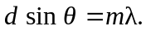
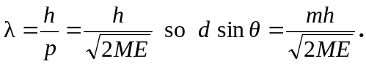
(Careful! Here, m is the order of the maxima, whereas M is the mass of the incoming particle.)
a) 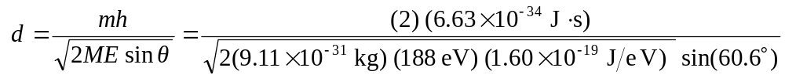
b) m = 1 also gives a maximum.
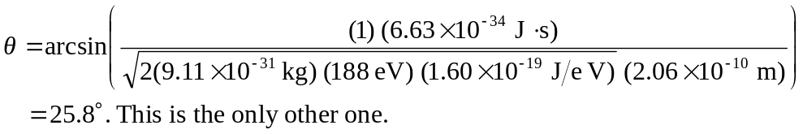
If we let 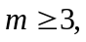 then there are no more maxima.
c) 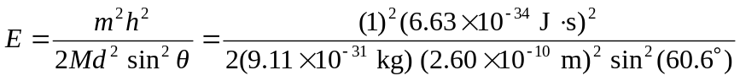
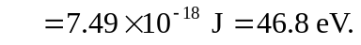
Using this energy, if we let maximum in this case.

